Rail Period 2703 performance target failure – T3
Time to 3 (T3) - The percentage of station stops called at within three minutes of the planned time, for all trains in each reporting period.

- the cause(s) of the relevant Performance Target Failure

Prior to 24 June, the Northern Moving Periodic Average (MPA) for Time-to-3 was 80.20%; in the subsequent days this deteriorated to an end-of-period result of 78.99%, 1.21% behind target.

From 19 June, the hot weather started to impact both Northern fleet and Network Rail infrastructure, with punctuality declining as shown in the graph below. Due to the sustained nature of the hot weather, it was necessary to implement an amended timetable across parts of the Northern network from 23-27 June.

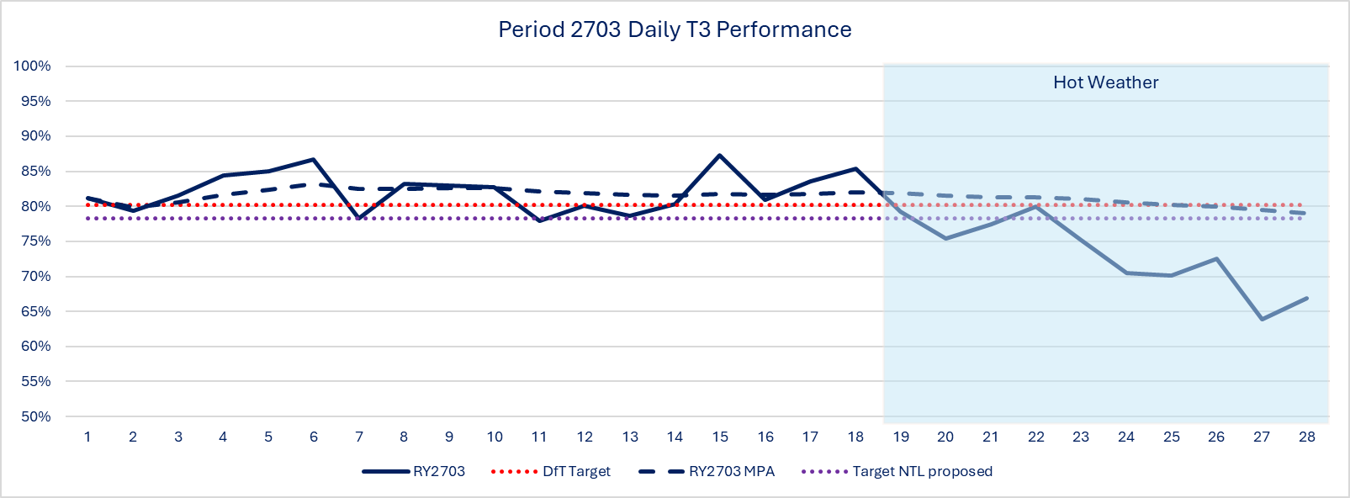

The hot weather also had a significant impact on the following KPIs.

 | P2703 | T3% | %
NTL Engineering non-Technical | 4650 | 0.64% | 0.2%
NTL External | 6765 | 0.93% | 0.2%
NTL Operations | 3195 | 0.44% | 0.1%
NWR External | 16551 | 2.27% | 0.1%
NWR non-track assets | 16231 | 2.23% | 0.1%
NWR Planned | 2334 | 0.32% | 0.1%
NWR Severe weather/ Autumn & Structures | 4643 | 0.64% | 0.3%
NWR Track assets | 6655 | 0.91% | 0.1%
OTOC Engineering Non-Technical | 1110 | 0.15% | 0.1%
OTOC Engineering Technical | 7974 | 1.09% | 0.3%
OTOC External | 2375 | 0.33% | 0.1%

Several Emergency Speed Restrictions (ESR) were implemented across Northern routes due to Critical Railhead Temperature (CRT).

Top 10 incidents for T-3 Failures during period 2703:
Incident Text | T3 Failures
Track Circuit Failure Leeds | 1,557
20mph Heat Speed Restriction Bridlington - Beverley | 1,112
Overhead Line Failure Manchester Piccadilly | 937
Overhead Line Damage Manchester Piccadilly | 872
6H58 Freight Failure Manchester Victoria | 730
Trespass Lostock | 724
1h92 Train Power Fault Deansgate | 708
Level Crossing Misuse Deansgate - Astley | 646
Fatality Leyland | 596
30mph Speed Restriction Accrington - Huncoat | 589

In addition to the above, we faced disruptive incidents linked to Northern trains overheating in traffic. This resulted in prolonged maintenance requirements when trains returned to Train Care Centres, with a knock-on impact on availability challenges for the remaining fleets over the subsequent days of the hot weather. This also impacted the short-formation and cancellation metrics.

Overcrowding on services and changes to service formations in response to the amended timetable also had a knock-on impact to T-3 performance. This was further exacerbated due to planned engineering works reducing the availability of services across key corridors.

- (if applicable) the action(s) that the Operator is proposing to take to remedy such Performance Target Failure

Northern, Transpennine Express, Transpennine Route Upgrade and Network Rail’s North East and North West & Central routes all work closely together and as a group they are known as the North’s Railway

The North’s Railway is undertaking a detailed review of the preparedness for hot weather, focussed on fleet and infrastructure resilience. This will review existing plans, processes and communications.

Northern mitigation activities include:
- Ad-hoc cleaning at Traincare Centres of train radiators to clear debris and pollen accumulation
- Class 158 cab messaging providing guidance to traincrew on isolating heaters
- Risk Management – resourcing, health & wellbeing, workload
- Review of Northern Emergency Weather Action processes
- Review of Northern fleet seasonal preparedness
- Review of communications to frontline colleagues and customers

