Rail Period 2702 performance target failure – T3

- the cause(s) of the relevant Performance Target Failure

Prior to 21 May, the Northern Moving Periodic Average (MPA) for Time-to-3 was 82.68%. In the subsequent days this deteriorated to an end-of-period result of 78.90%, 1.78% behind target.

From 22 May, the impact of the hot weather started to impact both the Northern fleet and Network Rail infrastructure, with punctuality and reliability seeing a worsening trend as visualised in the graph below. Although the extreme weather only lasted one day, it remained above seasonal averages for over a week.

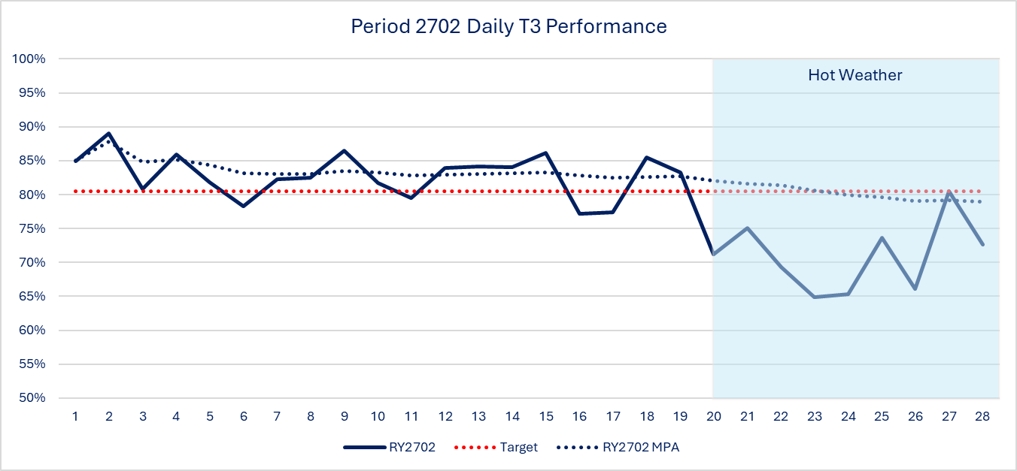

This unseasonally warm weather deterioration in T3 performance had a significant impact on the following KPIs:

KPI | P2702 | T3% | Diff vs P2602%
NTL Engineering Technical | 15594 | 2.10% | 0.5%
NWR non-track assets | 18661 | 2.51% | 0.8%
NWR Sever weather/ Autumn & Structures | 4733 | 0.64% | 0.3%

Several Critical Speed Restrictions (CRT) were forecast to be implemented across Northern routes. Reviews of the highest impacting speeds were carried out and assessed to be within tolerance of the timetable, and no emergency timetables were executed as a result on asset availability. There were several locations where CRT were implemented following major infrastructure renewals carried out by TRU.

Whilst there would be challenges to punctuality (T3), the risk to reliability (cancellations) was minimised.
Incident | T3 Failures
OVERHEAD LINE FAILURE – DARLINGTON | 714
OVERHEAD LINE FAILURE – MANCHESTER PICCADILLY | 682
OBJECT ON THE OVERHEAD LINE – LANCASTER | 638
LIGHTNING STRIKE - LEEDS | 526
TRACK CIRCUIT FAILURE – SELBY | 517
OVERHEAD LINE FAILURE – POTTERS BAR | 510
1N69 BRAKE ISSUES SALFORD (323227) | 479
FATALITY – WELWYN GARDEN CITY | 450
SIGNALLING SYSTEM FAULT – GLAZEBROOK | 419
OBJECT ON THE LINE - MEADOWHALL | 417

There were numerous major infrastructure failures across Northern due to weather-related issues, including Keadby Swing Bridge in South Yorkshire and overhead line equipment in Greater Manchester. There were also challenges of major off-route incidents impacting Northern services.

We faced disruptive incidents linked to Northern trains overheating in traffic, resulting in prolonged maintenance requirements when returned to Train Care Centres, which then resulted in availability challenges for the remaining fleets over the subsequent days, impacting both short-formation and cancellation metrics. There was also an increase in customers requiring medical attention due to warmer conditions on Northern services.

Overcrowding on services linked to the above incidents and short forming of services caused a knock-on impact to T3 performance. This was further exacerbated due to planned engineering works reducing the availability of services across key corridors.

- (if applicable) the action(s) that the Operator is proposing to take to remedy such Performance Target Failure
The North’s Railway is undertaking a detailed review of the preparedness for hot weather, focused on fleet and infrastructure resilience. This will review existing plans, processes and communications.

Northern mitigation activities:
- Ad-hoc cleaning at Traincare Centres of radiators to clear debris and pollen accumulation
- Class 158 cab messaging providing guidance to traincrew on isolating heaters
- Risk Management – resourcing, health & wellbeing, workload
- Review of Northern Emergency Weather Action processes
- Review of Northern Fleet seasonal preparedness
- Review of Communications to frontline colleagues and customers

